Group Report: Team 2

Description of the Field
We, a team of 18, reached the first field (Guptanagar) at 8:30 in the morning. To our utter surprise, there were people already in their shops working. We divided ourselves into small groups and decided to talk to different people. The locality can be best described as a construction site on one side of which metro construction was been undertaken and on the opposite side, there were small houses and shops. The site had both an advantage and a disadvantage. The former being the large abundance of varying jobs that existed in the locality. However, there were no specific industries as such which limited our discussion as some people lived in the area but worked somewhere else and couldn’t do anything but believe every word they said. First, we came across a shop of wheat grinder. The old lady was alone at the shop and his sons were away. On being asked about the problems she faced, she replied she faced no problems (she couldn’t realize because she repeated the same task day after day, week after week). Her shop had a big weighing machine with various different weights and large number of jute bags with wheat in them. The locality had large number of auto drivers lined, waiting for people or sleeping in their vehicles. We also met a sugarcane juice seller with whom we had a detailed discussion. His shop was a small set up with a few chairs and a temporary shed covering his space. A lot of old women were also busy picking up the waste from the area as all the waste was dumped at one place and these women were assigned to segregate the waste and collect it. There were a large number of fruit and vegetable vendors on the street. We saw a couple picking up the soil particles, dust and stones on a jute bag and placing it at the back of ass. We saw small children following us when we were interviewing the elders. They felt like celebrities and their happiness was visible as they had been ignored for so long that when we interrogated them, it made them feel special. On going into the smaller streets, we met cobblers, toy makers, laundry shops, street cleaners and others. They all had their problems and gave us an elaborate explanation about them. We met small retailers who told us how they have been affected by demonetization and GST implementation and we observed closely the way they work. We also observed the making of houses of these people. Majority of women worked as home makers in the area. The distinction between rich and poor was quite evident as we could see both small kaccha houses and big multiplexes from a distance.

General Description and Observations:

As we reached the field, we spread out all over the location to identify the problems. Guptanagar was an underdeveloped slum area where living colonies, roads, water drainage and waste management facilities were not in good condition. At a first glance, the general problems observed can be divided in two categories :
1. Domestic:
- The houses were constructed a long time ago and as the roads were made adjacent to them at a certain elevation, they got sunken in the ground. No drainage system was present so the natural tendency of water flow would be inside the houses. The roads were very narrow and blocked at a few places by either vehicles or stray animals.
- Men who lived in those houses were mostly labor workers, autorickshaw drivers, vendors or unemployed. Women were maids who worked in nearby residential buildings.
- The slums which did not have a concrete roof, had no method of harvesting water. They could not place a syntax tank over the roof or an underground tank. Either they had to travel all the way to public sources to get the water in buckets and pots or they stored it in small tanks where there was a high chance of infection.
- The obvious urban problems were present like air pollution, noise and sound pollution and bio and non-biodegradable waste spread all over the place in heaps which caused foul smell and gave birth to mosquitoes and parasites.
2. Professional or Industrial: The field had various small scale professions.
- Fruit and vegetable vendors: These vendors used trolley carts to transport the fruits and vegetables to their preferred locations and sell them. They had hired a rickshaw or a tempo to deliver the fruits and vegetables to their houses from the Mandi and then they used to load it on cart and start their day. They used to manually push and steer the cart using muscle force. They used polythene bags to pack the fruits that were sold.
Problems Identified:
“The vegetables that are being transported from Mandi to the vendors in auto and tempo gets suffocated in plastic bags and the ones which are at the bottom gets crushed as well.”
“The trolley has ordinary flat design, while transporting it may fall down the edges or get eaten up by cows and animals.”

“The handling, steering and breaking of the cart is all done manually and requires immense human effort.

- Sugercane Juice Vendor: The seller has invested his capital in the machine and it was used only two months a year during the summer. There was no alternate application of the machine to get profit from during off season.

- Toy Maker: A small scale industry of workers who make handmade stuff toys with dry grass. The sales and profit were very low and the production was not very effective. The dry grass edges often resulted in cuts on hands and fingures.

- Cobbler: A cobbler had his own temporary stall in the corner of crossroads. He used basic tools to do his tasks. The tools were inefficient, required a lot of human effort and presented a risk of damaging his fingers while stitching.

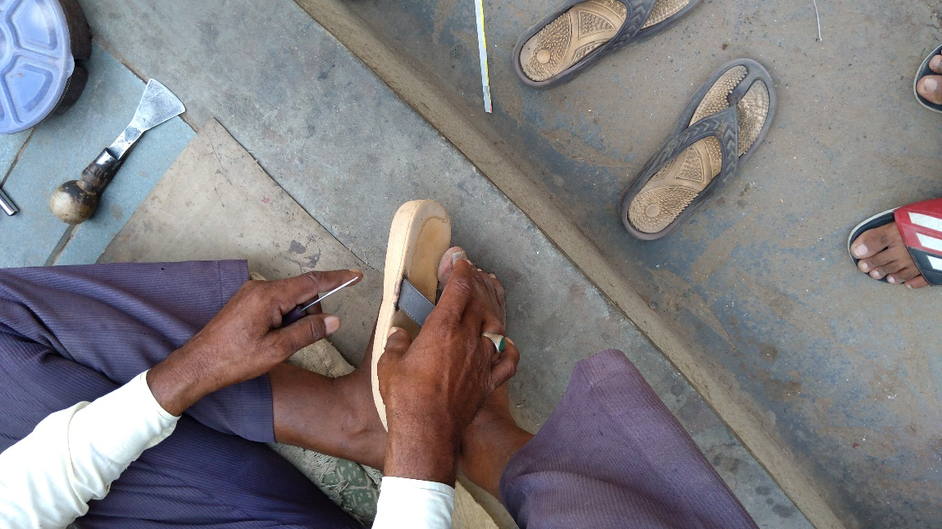
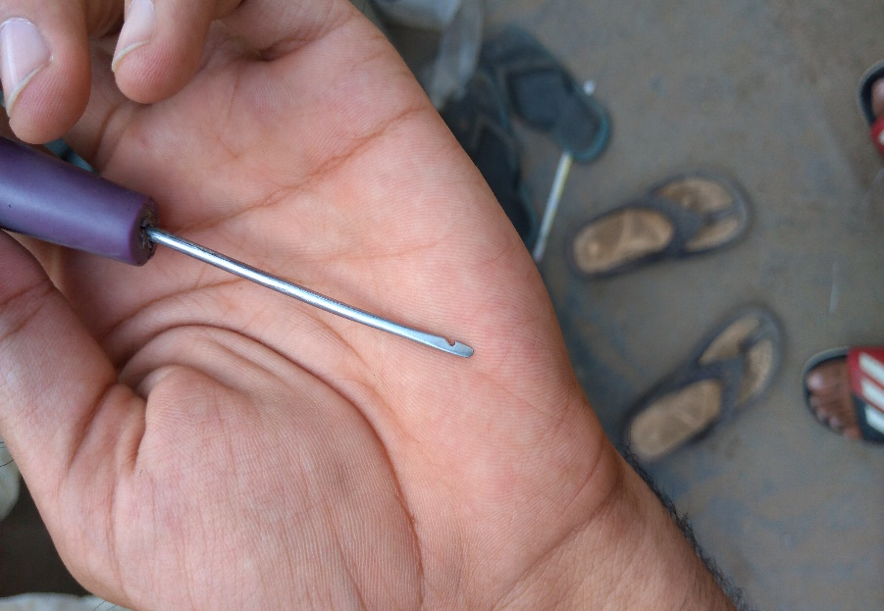

- Laundry and ironing shop: A married couple were running a laundry shop in a rented room where they lived as well. They used charcoal iron to iron the clothes Even in the heat, they could not turn on the fan as it provided excess air flow which resulted in sparks in the coals resulting in possible burning of the cloth.
Also, the iron weighs heavily with the added weight of coal that caused pain in the arm, shoulder and back of the user.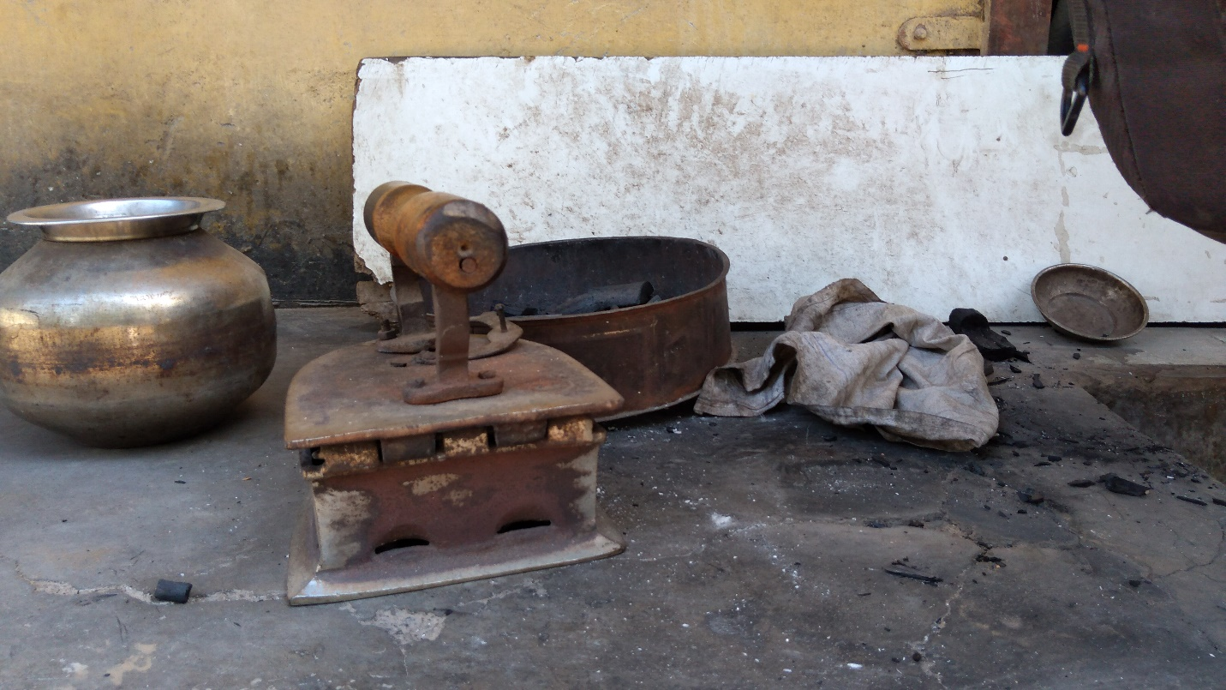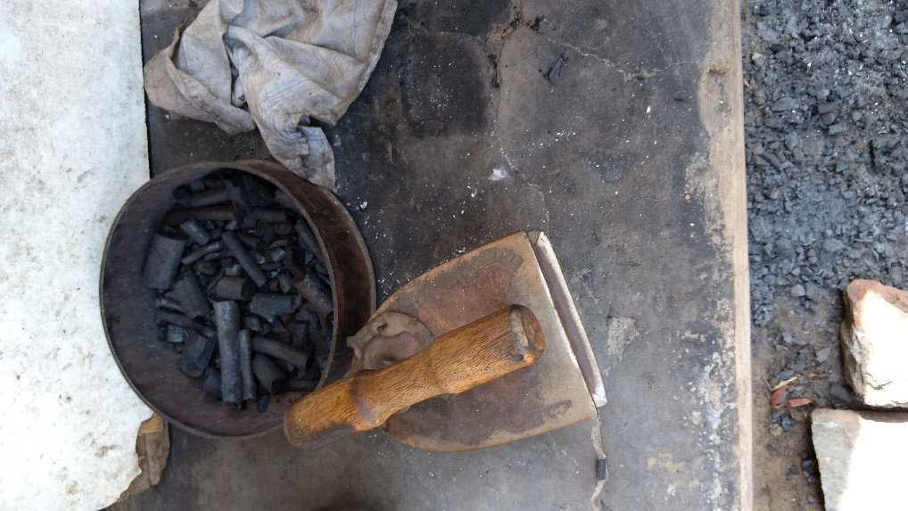

- Autorickshaw Driver: Auto driver delivered fruits and vegetables to vendors everyday and then milk, bread and eggs to the shops as well. These goods left a smell in the auto and that would attract the animals like dogs and cows which would come in search of food and tear the seats.
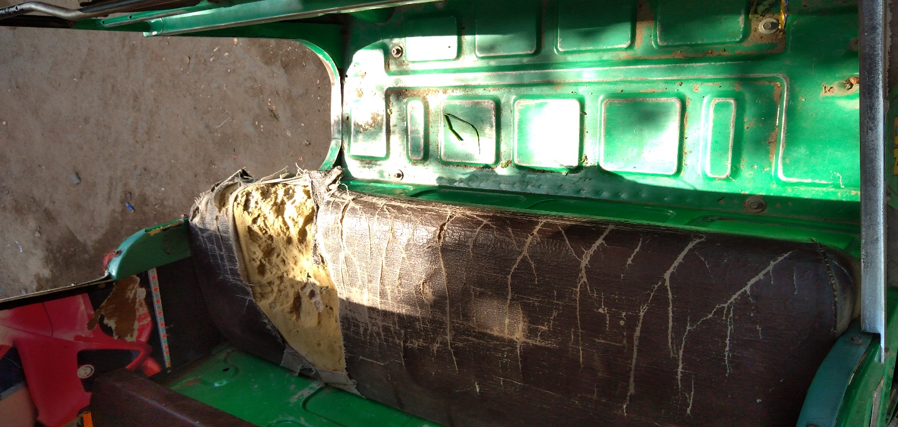
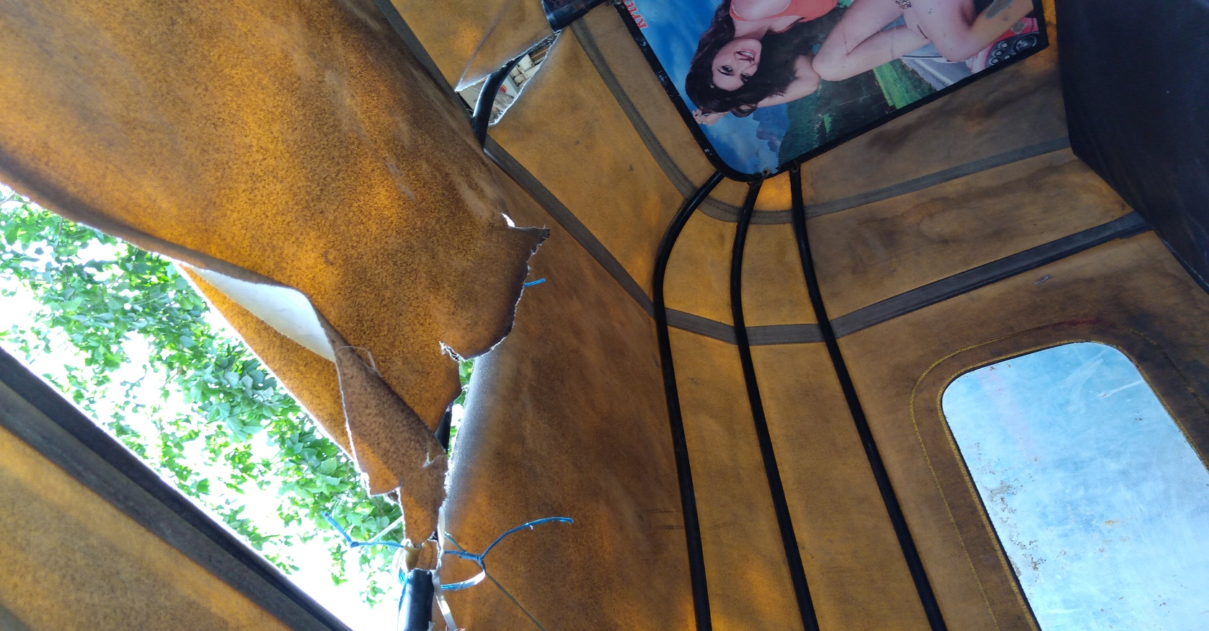
- General Store shopkeeper: He sells glossaries, food items and milk products as well but does not have enough space to stack them up properly. In order to reach the highest rack, he used a chair on a rice jutebag and climbs on to it. There is no other mechanism to reach out to far fetched items.
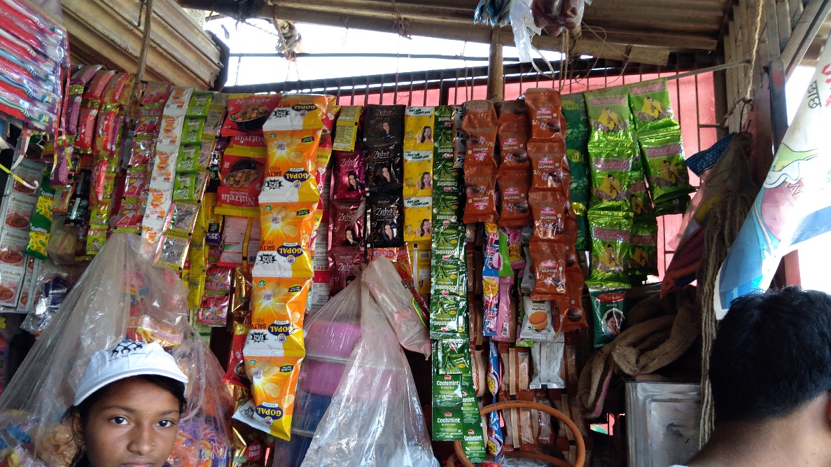
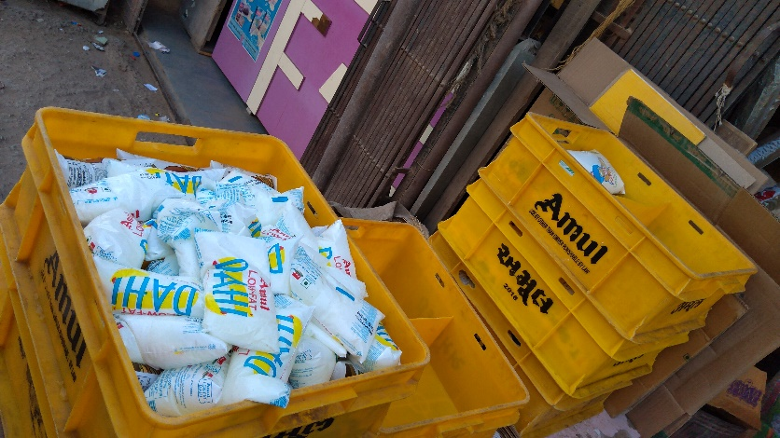
- 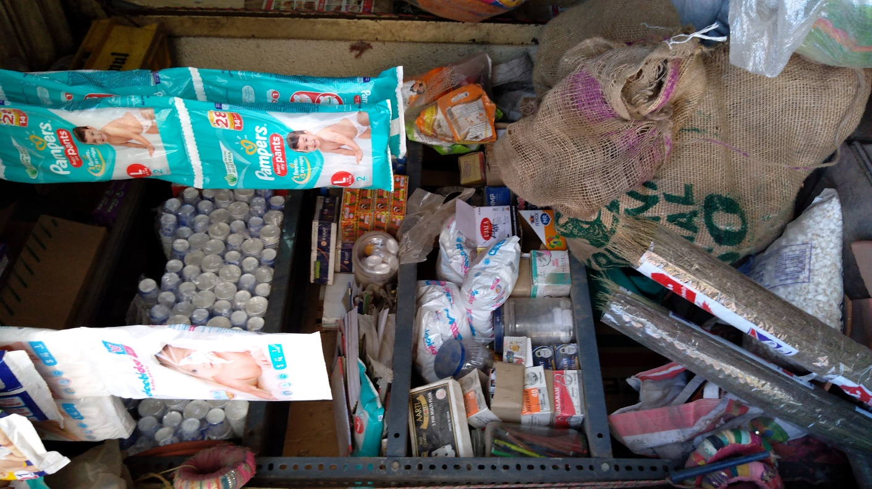

Problem 1:
The first problem statement is related to laundry shops. The people working in these shops faced majorly three problems: air circulation, heavy weight of iron, unaffordable electricity charges and safety issues.
Air circulation is a problem for those who iron as these people work in extreme temperatures in the summers and hot iron which runs on coal adds to their problem. These people cannot use fans or coolers because it ignites coal even more and causes sparks to come out of iron.
The iron weighs around 5 kg and the workers add 1 kg of coal which makes iron quite heavy to work with. The reason behind adding 1 kg of coal is that it ensures proper heating. Also, if they add the mentioned amount but do have enough clothes to iron, then the coal gets wasted adding to their losses.
They cannot afford electrical irons because of their high price and the need to install separate meters which adds to the cost.
While ironing clothes, these people are prone to get burnt and hurt by the nip of the iron as it touches their fingers repeatedly.
Solution 1:
The solution to air circulation is multifold. We can use a transparent top which covers the entire working space and does not let air reach the iron. A more sophisticated solution can be derived from baby incubators which have covered tops and simply hands go inside and do the work.
We can place a casing outside the iron which is going to light weight. It will have small ventilators which will allow flow of air needed for oxygen to burn and will also protect the iron doer from damage as the nip won’t touch the person.
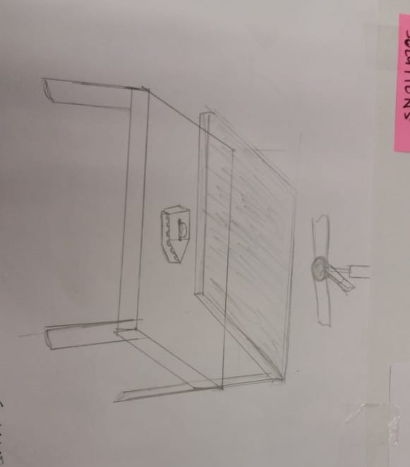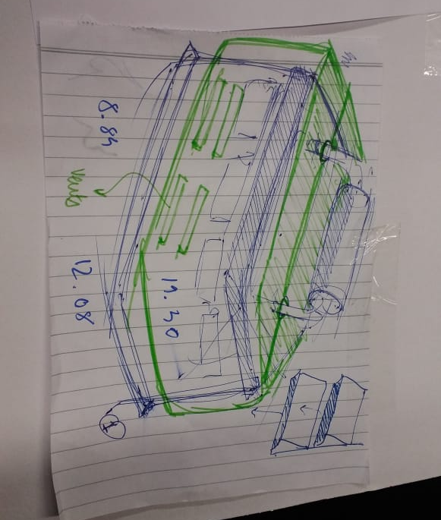
Problem 2:
The second problem is related to cobblers who till date use hand tools to make or repair shoes. The cobblers are mostly male with only a few women working I the profession. These people regularly use leathers, wooden sole, plastic and cloth to make or repair their product. These people have an extremely small workspace which is very compact. They usually sit alongside roads in extreme temperatures as their set ups are temporary and usually in places which can attract customers. The tools they use are leather cutters, needles, shoe stand, hammers and nails.
These people have no power supply and aren’t able to use any electronic tools because of very low income. Their work is also largely intuition based (sewing shoes) which makes them prone to getting hurt from hammers and sewing needles. Also the sewing of shoes requires a lot of efforts as the leather is so thick that a lot of force is applied to pass the needle through the shoe.
These people often face pain in their back, shoulders and hands due to to and fro movement of hand while polishing or cleaning shoes. A close look at their hands will reveal bruises and cuts. They also suffer from breathlessness because of dust and harmful odour of polish cream.
Solution 2:
To solve the problem of excess movement while polishing and cleaning a shoe, we have come up with a device which will use a motor and a cam shaft. The brush will move parallel to the shoe and clean and polish it.
To solve the issue of excess force and pressure required for needle to pass through the leather, we have designed a pen like structure with an inbuilt spring which will make it easier for the cobbler to pass the needle through the shoe. The design can be worked on in detail. The initial idea is to place the button on top of the pen like structure, which can also be placed on the side to ensure proximity to the needle for better precision.
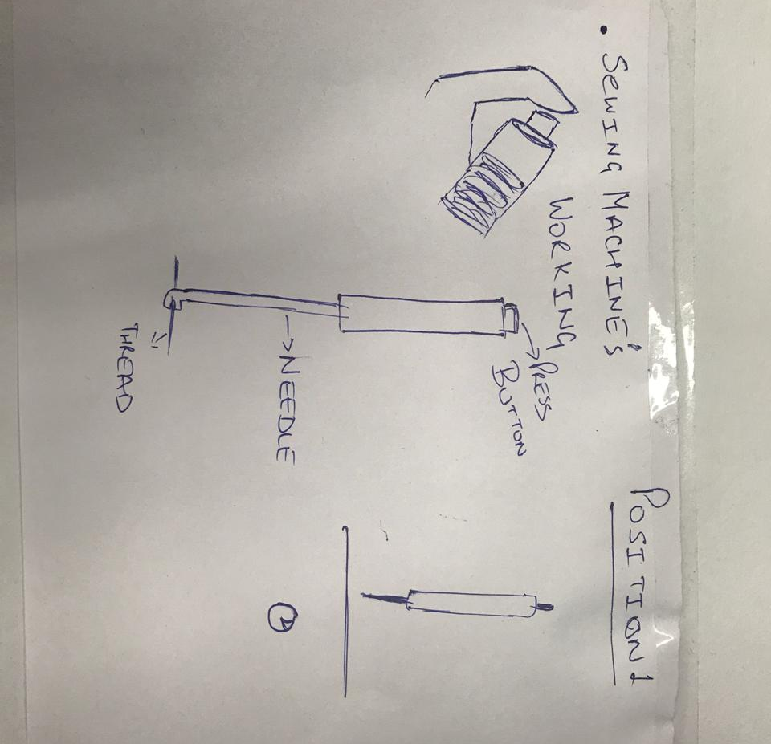

Problem 3: Redesigning the trolley cart.
Solution 3:
A cart presents a flat surface as the area to contain the vegetables. So compartment system (likes small -small partition system) can be implemented to give more stability as well as organizing the different vegetables in an ordered format according to their sizes and weight. For this we can either have wooden compartments which will be rigid and heavy or we can use hinges at the rim and make a jute cloth partition that would make them more flexible.
For Breaking, steering and controlling the cart, we borrowed the concept of trollies used in airports where breaks are always on until a leaver releases them. So similarly a steering handle connected with two breaks to two rear wheels is used here. The cart will be constantly stationary until the leaver is pressed to take the breaks off. This is called a repressive control. In biochemical reactions, operons use this method as well to regulated the expression of a certain gene. This is a fitting metaphorical analogy for the principle.
If one break is released and the other one is not then it allows the cart to turn 360 degrees with respect to the stopped wheel. This will allow the user to steer the cart in sharp turns and dead end alleys.
We also though of using castor wheels instead of the standard wheels to provide ease on maneuvering the cart .
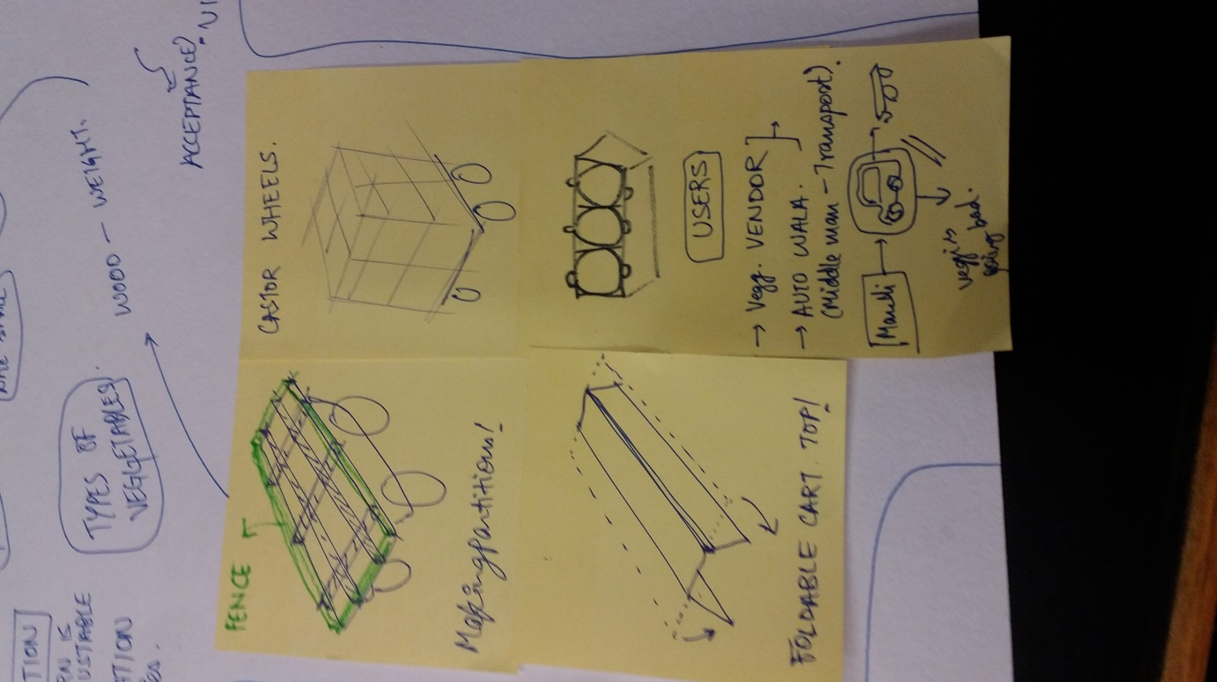

Group Contributions:
All the problems were discussed amongst us and we listed them down. Out of which we selected a few problems which required a redesigned solution desperately. We analyzed all the observations we got and made a flow chart of user, product and context. A collective ideation resulted in multiple conceptual solutions. Inputs from all the members helped in combining a solution for two separate solutions. We then made 3D models of the redesigned products on Solidworks software and visualized the solution and documented the entire ideation process.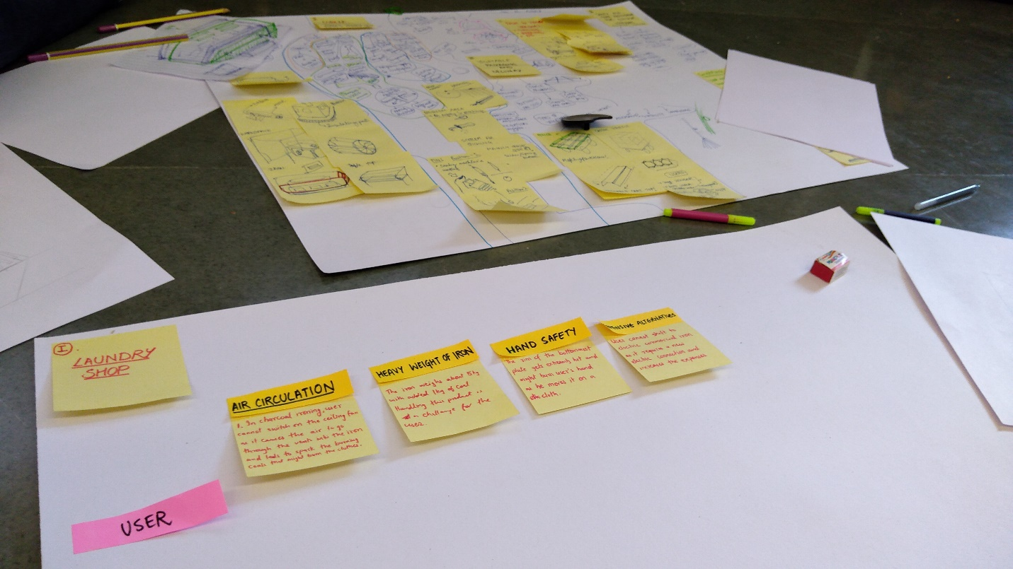
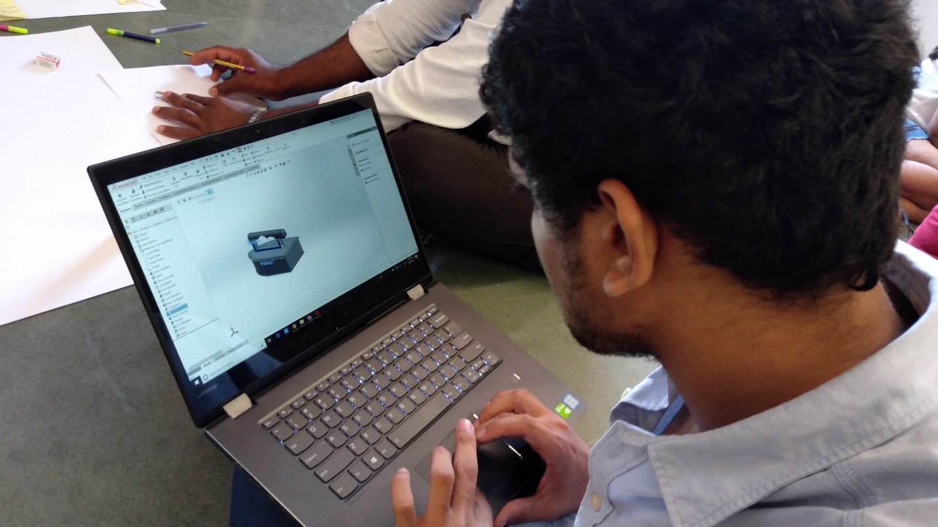
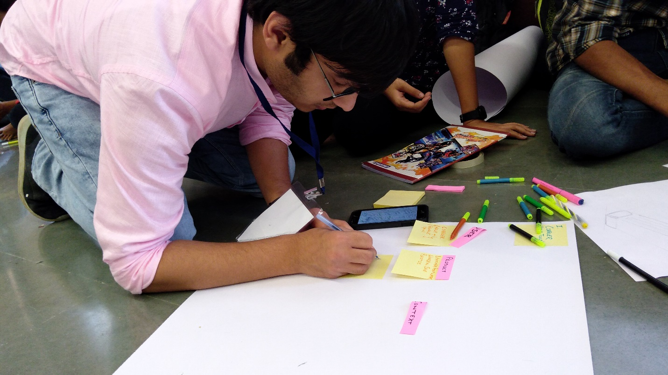
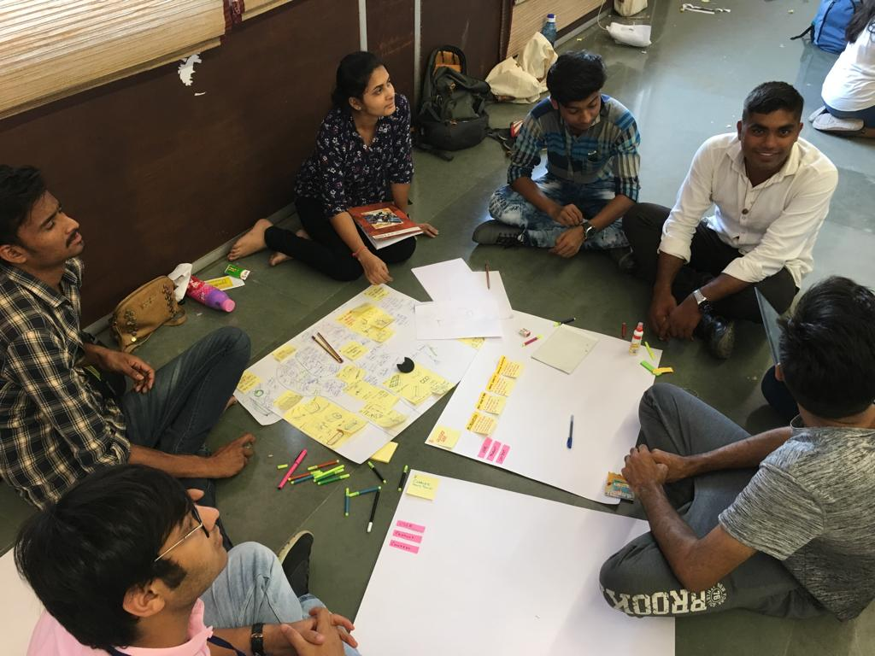
Conclusion
We got the opportunity to look closely to problems faced by people and professionals living in the slums. There are numerous problems that these people face and we simply ignore them willingly or unwillingly. We tried to identify these problems and tried to devise solutions by brainstorming. Our objective was to identify 5 most troubling problems and solve them. Our solutions were mostly feasible (atleast on paper). This entire process brought the team members closer and we looked at the problems with a lot of precision. The speech part was great as Mr. Anil K Gupta gave us a reality check and had counter questions for everything which made us realize that we need to delve deeper into the problems. The wholesome experience was great and an enriching one.
Difference Between Minors’ Ideas and Majors’ Ideas
The outlook of the two groups was very different over the two days. While the children had very objective view, the minors had a very subjective view.
- Children devised a way to clean the waste using the Bevel Gears. They thought of this idea from the Chuski Shops. The way the two wheels placed at 90 degrees make ice golas is what made this idea workable. Using the same concept, we can clean waste as the paddles will generate movement and cleaners at the bottom will clean the waste. Another student also devised a machine to clean waste using a manual machine. It will use two levers – one will clean the waste and the other will create suction to clean it. The majors also thought of cleaning waste but we thought of placing two long brooms at the end of the bicycle. As we run the bicycle, the brooms will move with the bicycle and clean the waste.
- The second problem that kids identified was of providing shelter to the cycle users. The major missed this issue. The children thought of placing an umbrella like structure will provide shelter against both heat and rain to the individuals who use bicycle.

The Presentation:
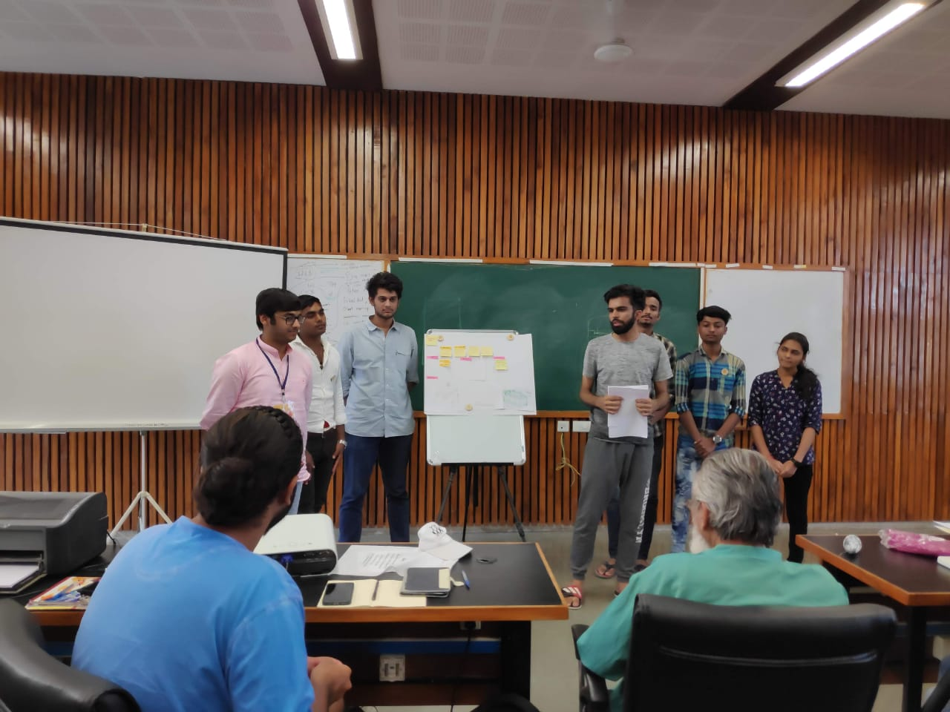

Retrospective Analysis:
- We could have asked more information about costs in production of different people in profession to estimate whether our design would be financially profitable or not.
- We could have done more extensive research on other existing solutions of the identified problems.
- We could have worked on making the solutions more viable and acceptable to people who are used to certain procedures to operate that product.
- We could have focused on peoples’s thoughts rather than observing the things they use.

