Field Visit Insights Report
Group 3

Group Members : Md. Zisan Khan, Pritish Pandya, Sakshi Thappa, Soumil Panwar, Uday Goyal, Utsav Malam, Yash Goyal, Arushi Rana

FIELD DESCRIPTION

Our team visited Hebatpur and Dilli Darwaza. Hebatpur is a small village where our team members came across a number of social issues on interaction with the villagers. The people had meagre incomes and most were dependent on cattle farming. Families owned cows, buffaloes and fed them fodder grown on their own fields. They were dependent on a community bore well in the middle of the village from where water was supplied to all homes. Some children attended government schools within the village, few went to farther schools. Power cuts were frequent, at least for an hour on a daily basis.
In Dilli Darwaza, we met people involved in wheat grinding, metal fabrication, and garland making. It was an industrial area with small workshops, with people working in small cubicles and dusty environment.

GENERAL INTRODUCTION

People had major water woes - water was scarce and of poor quality. Education was not accessible to all, kids could be seen working as labourers and some girls weren't sent to school for higher studies. Every household faced consequences of the extreme weather conditions - the ceiling fans weren't enough for cooling and people would often get rashes, or fall ill because of the heat. Electricity was expensive. Since many people practised cattle farming, looking after cattle was difficult - be it while taking them for grazing or in case of injury. Dogs weren't taken care of well, and had injuries. They fed their cattle, fodder grown in their own fields which wasn't always sufficient so they had to buy fodder at high prices to meet their requirements. The streets were filled with domestic wastes, water was thrown on roads after washing utensils or clothes and construction wastes were left in negligence.

In the second visit, the metal fabrication workers had no safety measures - their hands were injured and dirty. The lighting was poor and it weakened their eyesight. Dust particles filled the air, and the people worked their without any protective masks.

FIELD VISIT 1
Location : Hebatpur

PROBLEMS

A number of households depended on cattle farming. We noticed a number of problems in this -
- Cattle health : The high dependence on vets and treatment getting delayed.
- Fodder supply : Fodder was grown on fields and was not able to meet the requirements at all times. In that case, fodder had to be bought at high prices.
- Transport of milk : Costly and labour intensive. Moreover, workers did this job under the extreme weather conditions.
- Small market and production scale : Each family owned only 5 cows and could sell milk in the village alone.
- Storage of milk : Milk that was produced in a day was transported that day itself and there weren't enough measures to store milk in case of an excess.
- Weather woes : The homes lacked efficient cooling methods and people faced health conditions because of the heat.

Water
- Insufficient and poor quality water supply
- Unhygienic storage tanks 2hich had microbial growth
- No mechanism for treating or directing waste water

Education
- Girls were denied higher education
- Differently abled children had no access to school
- There were no high schools in the village.

Waste Management
- The streets were full of domestic wastes, including mostly plastic wrappers
- Water, after being used in washing clothes/utensils was thrown on roads after use
- Children played in unhygienic surroundings
- Construction waste was left in neglect, which had the potential of being reused and upcycled

Construction Labourers
- Child labourers bearing heavy loads
- Possible occupational hazards because of lack of safety measures and inefficient equipment
- Insufficient lighting, labourers worked in the dark
- Unhygienic living conditions - the labourers' families stayed at the construction site

Shoemakers
- Dying art, only one shop remains with two workers.
- No means of scrap management
- Back pain involved in the process, weight of one shoe was 1kg
- Only 1 shoe produced in a day - extremely small scale of production

SOLUTIONS

1. TERRACE FARMING FOR INCREASED FODDER PRODUCTION + WATER USE + COOLING
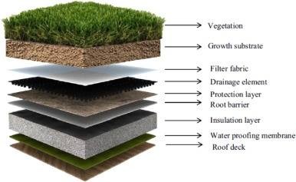
The villagers had houses with large terraces. We can design a system wherein fodder is grown on the terrace of the houses, from where water could be used for cows as it gets filtered through the soil layers, in which the fodder is being cultivated. This way fodder can be grown on the terrace as well as the fields increasing the production scale and avoiding the situation of buying fodder. Besides, terrace farming can help in cooling of the entire house, without employing electricity.

2. COOLING BY PLASTIC BOTTLE AC
A waste management application, the plastic wastes of the village - which include plastic bottles - can be used in the manufacture of ACs based on the Venturian effect.
Since the traditional design (originally adapted for protection from burglary) of most homes included an entrance with a wall of jharoka, these could act as the holes required to fit the plastic bottles. This could provide maximum cooling effect, with zero dependence on electricity, since the area experiences hot winds for most part of the day.

3. SOLAR THERMAL WATER PURIFIER
This self sustainable and easily operable purifier works on the concept of evaporation by lowering the atmospheric pressure and increasing heat. As it was evident that the area had ample supply of solar energy, this could be used to boil water rapidly which can then be passed through a condenser and collected as purified water.
The sunlight is concentrated on the tube carrying oil using parabolic mirrors. This oil will carry heat to the water tank and exchange heat through a heat exchanger inside the closed water tank thereby boiling the water and vaporising it. The pressure inside tank will be kept lower than the 1 atm. During night time we can use a solar thermal battery consisting of wax and oil which has stored solar energy.

4. HEALTH CHECK UP DEVICE

Taking inspiration from a fitbit watch, we can make a wearable device, strapped on the legs, for not only cattle but other animals which can be linked up with a mobile app. This can be used to indicate efficiency of cattle and other indications.

5. FIRST AID FOR CATTLE
We thought of making a scrub which can be directly applied to the skin of the injured animal. The scrub helps in healing as well as protection of the wound from external agents. Thus recovery will become as fast as possible, since there would be a some first aid available for the animal for the time before the vet arrives.

4. AN EDIBLE SHELTER FOR CATTLE
Fodder can be grown using existing technology and be fed to cattle from the roof.
Problems addressed : weatherproofing, growing fodder elsewhere, temperature.

5. EDUCATIONAL KIT FOR DIFFERENTLY ABLED CHILDREN
If Naina* can't go to school because she cannot walk, why not bring the school to her home? If she's scared to go to school because of her condition, we could help her build her confidence by introducing her to basic learning through fun games that also enhance her body movements. Henceforth she would be able to get schooling that is necessary at her age and at the same time prepare herself to face the world.
(*Name changed)

6. WALKER FOR DIFFERENTLY ABLED CHILDREN
Differently abled children have the right to freedom and an independent lifestyle to some extent. Their natural body movements of a child could be used to direct a criddle enabling the child to move around. Proper safety has to be developed into the device to keep the child safe.

7. PHYSIOTHERAPY FOR DIFFERENTLY ABLED CHILDREN
A preventive solution for self development of the muscular abilities of a differently abled child. This could enable it to perform tasks that it couldn't because of unequal growth of body physiology.

FIELD VISIT 2
Location : Dilli Darwaza

PROBLEMS
- The labourers carried heavy weighing sacks everyday and still did not earn well through this work.
- Labourers experience muscular pain and internal injuries.
- Lack of safety measures for workers of metal fabrication
- Hazardous work environment in the workshops
- No proper lighting in workshops
- Air pollution in the area
- Garland makers did a strenuous and meticulous job using traditional methods which were slow. They had no safety measures to protect themselves from getting hurt. Moreover, dried flowers weren't put into use and were simply thrown away.

SOLUTIONS

1. SLINGSHOT LIFT
Bags of sand and cement could be directed into hollow cylindrical ducts to reach the desired height and a lock could engage to stop the bag at certain floors. This upward thrust could be provided either manually or mechanically but it has to be calibrated according to the height of the building.
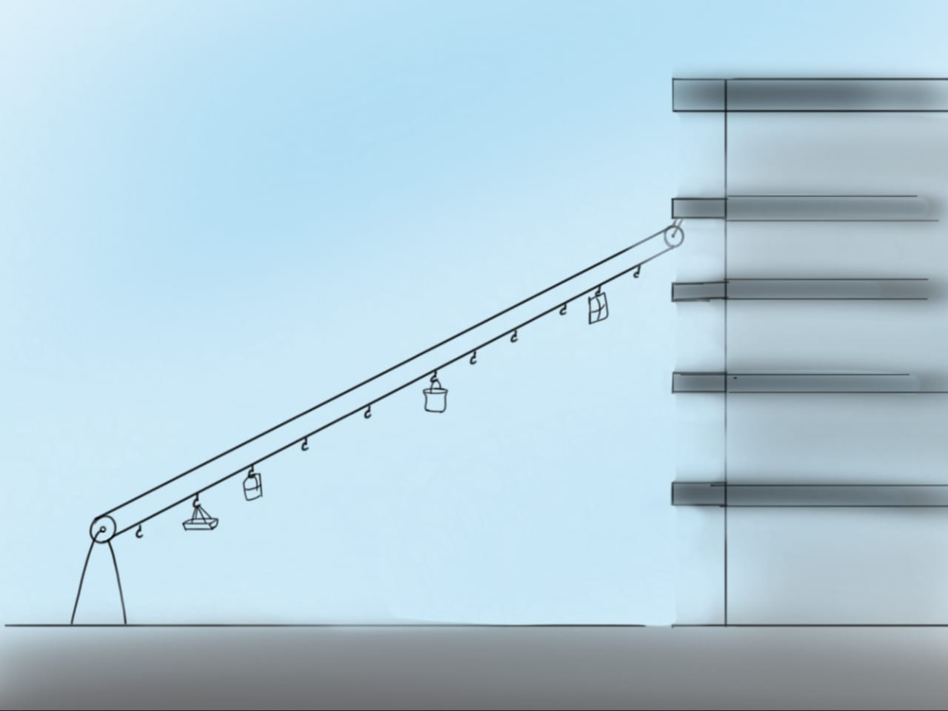

2. SACK TRANSFER MACHINE
Using two pulleys and rope with hooks, we can make a ropeway to carry sacks from one place to another either automatically or manually. This way, 2 or more sacks can be transported in one round, making the job less manpower intensive, fast and efficient. This method is better in terms of its easy construction, low cost and low space requirements.

3. SCREW POWER LIFT
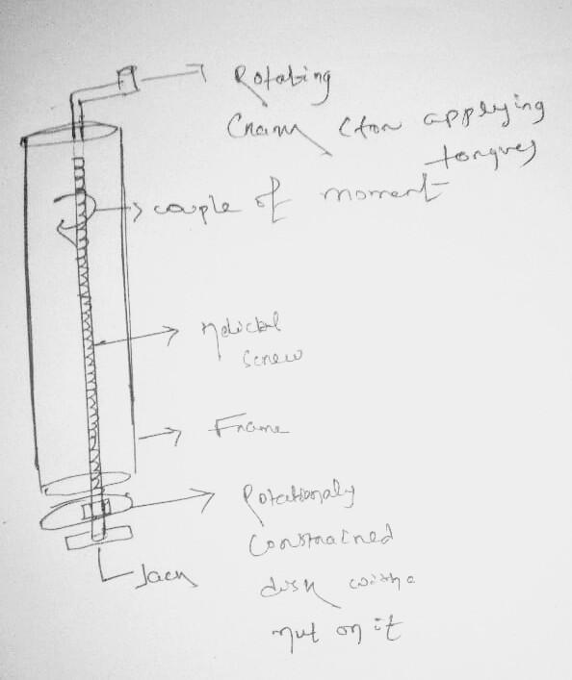
We have made a simple lift based on the concept of screw power transmission. We can create a screw lid which is fixed vertically and can rotate. For lifting load we have circular plate in a steel frame to which is attached a nut that is rotationally constrained. When screw will rotate the load on the constrained plate will move upward due to power transmission.

By applying little amount of effort we can lift at least 300 to 500 kgs easily to 5 to 6 storey building.

CONCLUSIONS

The two field visits gave us a good insight into the struggles of the localities and the working class. The living conditions were strenuous and the working conditions did not match up to the recommended safety norms. The attitude of living in these conditions was evident, and most problems have continued for years.

It was indeed an eye opening experience, wherein we got to see the small scale industrial work in front of our eyes. The decent living and daily struggles of the locals got us thinking about the economic divide and our privileges.

